

Dynafit Speed Radical Toe Piece and Adapters

This guide will walk you through the steps on mounting your new Dynafit Speed Radical Toe Pieces to your splitboard, using the Spark R&D Dynafit Adapters. Follow these instructions and you will be set up and ready to go in just a few minutes. Additional information and answers will be available on our website: www.sparkrandd.com or feel free to call us any time at 406.580.7674.

Included in this kit
- 2 pair of Dynafit Adapter plates
- 15 M6-10mm screws
- 9 M5-10mm screws
- 9 Internal Tooth Lock Washers

Tools Needed
- #3 Phillips Screwdriver
- #2 Phillips Screwdriver

1. Remove the Voile touring bracket and heel risers. Using a #3 phillips head screwdriver, install the Spark R&D Dynafit Adapter Plates using three M6-10mm Phillips head screws.

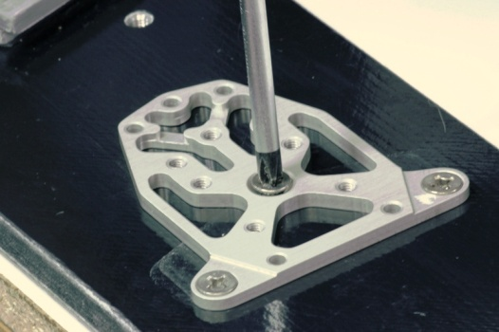

2. Place the Dynafit Speed Radical Toe Piece on top of the adapter plate. Using a #2 phillips head screwdiver, attach the toe piece using four M5-10mm screws and four lock washers. WARNING: Lock washers must be used to avoid screws hitting your board.

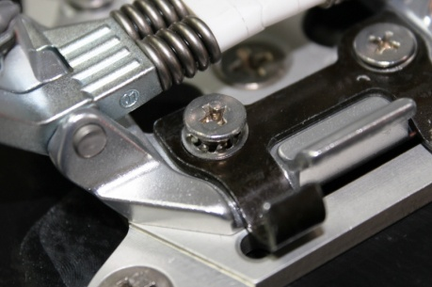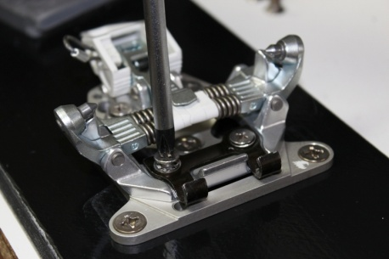
3. Click your boot into the toe piece to determine proper placement of the heel riser. The riser should contact the heel of your boot, not the arch.

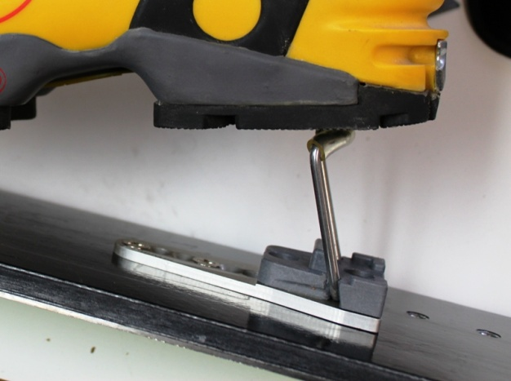

4. Using a #3 phillips head screwdriver, attach the heel adapter to the board using two M6-10mm screws.

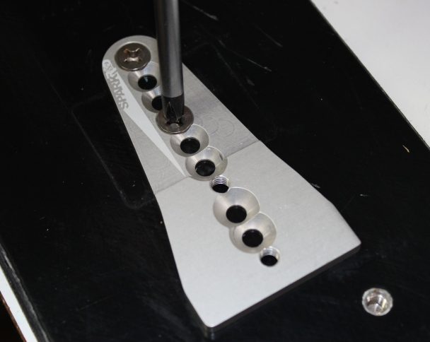

5. Using a #3 phillips head screwdriver, attach the heel riser to the board using two M6-10mm screws.

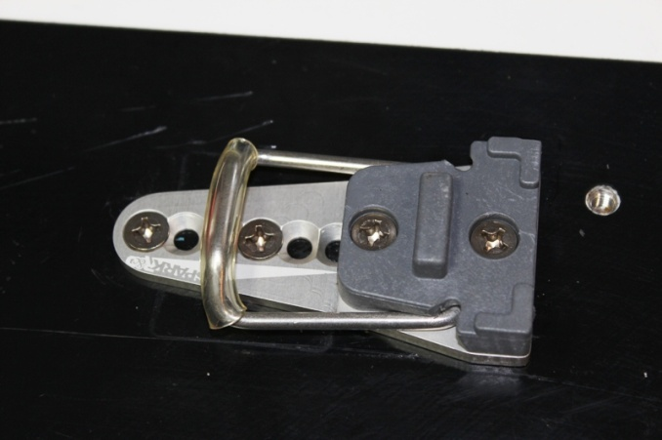

Your install is complete.

